**Downloading low resolution CTD data on 11 March 2025**

In ices data portal <https://data.ices.dk/view-map?theme=201809>, I draw a polygon for each subpopulation according to the habitat area, to obtain the CTD low resolution data within the polygon.

**For northwestern subpopulation:**

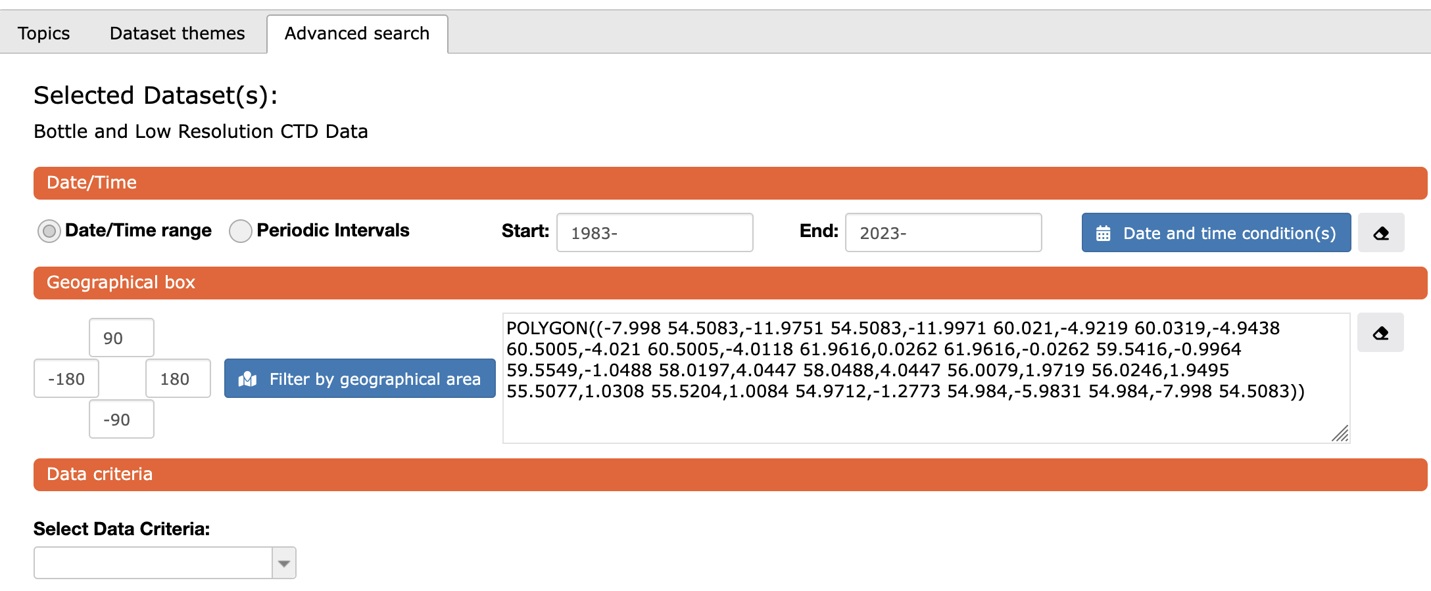

POLYGON((-7.998 54.5083,-11.9751 54.5083,-11.9971 60.021,-4.9219 60.0319,-4.9438 60.5005,-4.021 60.5005,-4.0118 61.9616,0.0262 61.9616,-0.0262 59.5416,-0.9964 59.5549,-1.0488 58.0197,4.0447 58.0488,4.0447 56.0079,1.9719 56.0246,1.9495 55.5077,1.0308 55.5204,1.0084 54.9712,-1.2773 54.984,-5.9831 54.984,-7.998 54.5083))

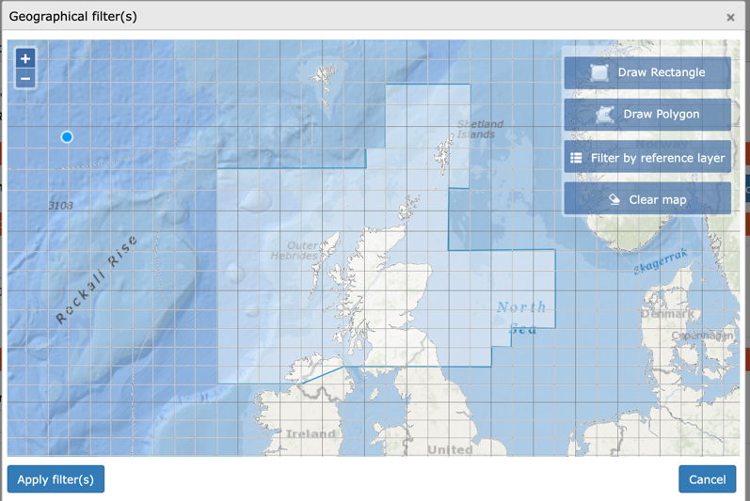

**for viking subpopulation:**

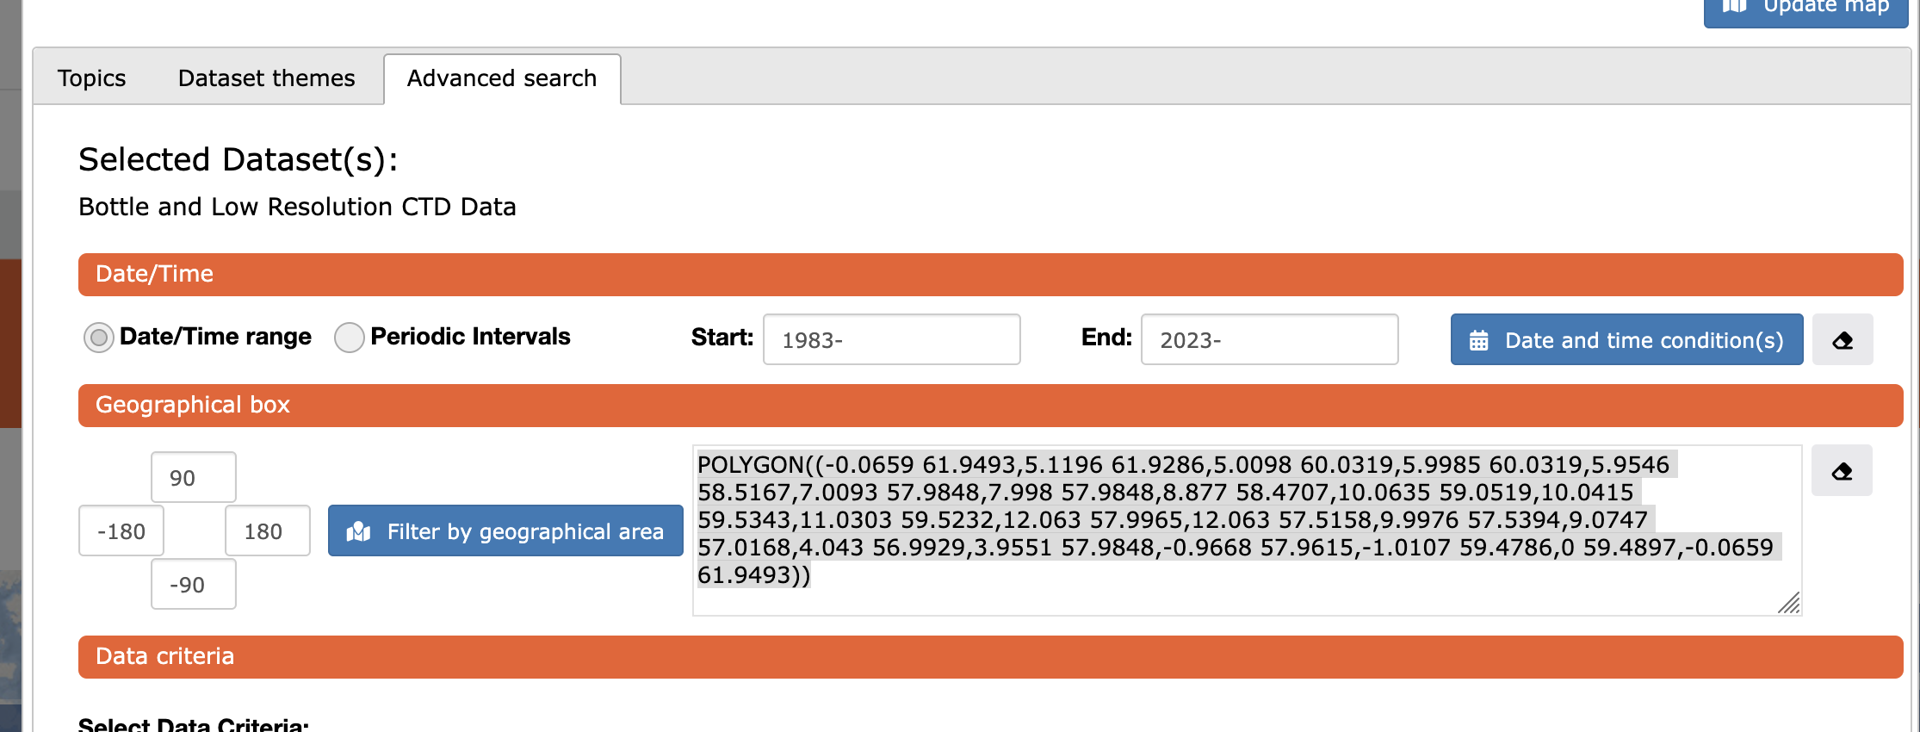

POLYGON((-0.0659 61.9493,5.1196 61.9286,5.0098 60.0319,5.9985 60.0319,5.9546 58.5167,7.0093 57.9848,7.998 57.9848,8.877 58.4707,10.0635 59.0519,10.0415 59.5343,11.0303 59.5232,12.063 57.9965,12.063 57.5158,9.9976 57.5394,9.0747 57.0168,4.043 56.9929,3.9551 57.9848,-0.9668 57.9615,-1.0107 59.4786,0 59.4897,-0.0659 61.9493))

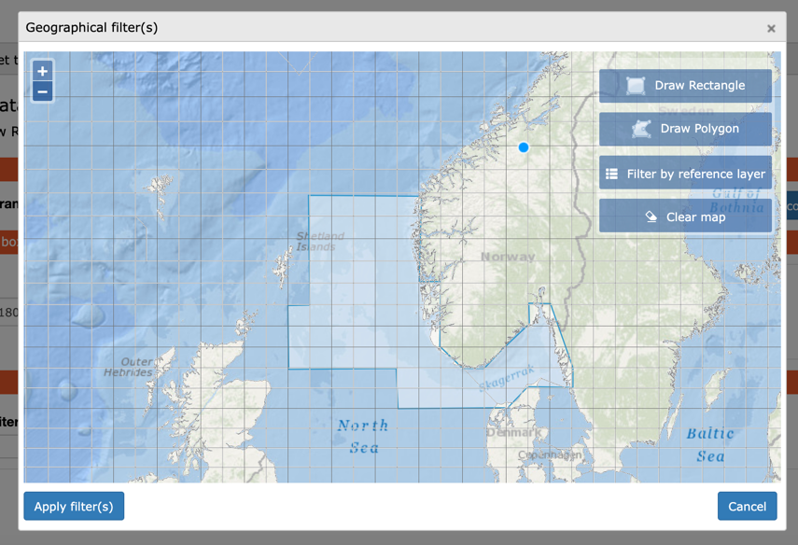

**For southern subpopulation**

POLYGON((-2.0654 50.6251,-2.0435 49.6249,-0.9888 49.3108,0.1318 49.2535,0.2197 49.6818,1.7139 50.036,1.626 50.8337,3.0762 51.2344,4.021 51.5361,5.0317 52.4962,6.0425 52.5095,6.0205 53.344,8.9868 53.4357,8.9209 56.9809,3.9331 56.9929,3.9331 55.9984,1.9556 55.9861,1.9775 55.5037,1.0767 55.5037,1.0547 55.0154,-1.4062 55.0028,0.0659 53.0016,0.9888 52.4828,0.9448 50.9307,-2.0654 50.6251))

